PROJECT REPORT

NAME = ARCHITA SINGH
REG NO = 25BAI11553
COURSE = PROGRAMMING IN JAVA

- Introduction
Student Course & Academic Management System is a Java command line application that was developed to manage student related academic data in an organized manner. The application helps the user in storing and managing the student’s information, course details, grades along with their enrollment records.
The software is capable of calculating the grade points of the grades and with the help of credit hours allocates the final GPA of the student. All the records are stored in the text files by the application through Java file handling.
The project showcases the use of classes and objects, encapsulation, ArrayList, methods, conditional statements, loops, and exception handling along with the input validation and file handling concepts of Java.

2. Problem Statement

Maintaining the student's data manually in an organized manner is a challenging task, including their courses, information about their registration, and grades. It becomes highly time-consuming to perform operations like searching for a particular record or calculating the average grade of a student.

The Student Course & Academic Management System is a java command line application that aims to offer an easy solution to manage students' basic academic information like grades and marks.

The application not only stores the grades of the student but also converts the grades into grade points and finally calculates the weighted average grade point as per the credit system of the respective course. It presents a complete academic report of the student with GPA.

All the records are stored in the text files using java file handling concepts.

The project demonstrates the implementation of Object-oriented programming, classes and objects, encapsulation, ArrayList, methods, input validation, exception handling, and file handling concepts in java.

3.Functional Requirements
The system should provide the following set of functional requirements.
FR1 – Student Management
Add a student’s data: ID, name, email, and phone.
View student data.
Search for a student by Student ID.

FR2 – Course Management
Add a course: course ID, course name, and credits.
View course data.
Search for a course by Course ID.

FR3 – Enrollment Management
Enroll a student in a course.
View enrollment data.

FR4 – Grade Management
Add a grade for every course.
Convert a grade into grade points according to the grade point system.
Calculate weighted grade points for every course based on the credit hours.

FR5 – Academic Report
Generate a student’s academic report.
View the student’s course, grade, credit hours, and grade points.
Compute the student’s GPA.

FR6 – File Storage
Store student data in the students.txt file.
Store course data in the courses.txt file.
Store student enrollment data in the enrollment.txt file.
Store student’s grade data in the grades.txt file.

5.Non-Functional Requirements
NFR1 – Usability
The application menues should use simple command prompt prompts and make it easy for a user to enter a command.
NFR2 – Reliability
The application should not crash when receiving incorrect input.
NFR3 – Maintainability
The application’s source code should be split into class definitions: Student, Course, Grade, and manager classes. This will make the code easy to read and maintain.
NFR4 – Error Handling
The application should be able to process numeric user input. It should also handle file reading/writing exceptions using C++ built-in exception handling mechanism.
NFR5 – Storage
Student records, course catalog, enrollment data, and student grades should be saved in separate text files upon exit or during application execution to persist data between application sessions.
NFR6 – Performance
The application should handle student and academic record management for a small scale efficiently.

5) DESIGN DIAGRAM

System Architecture
The project follows a modular object-oriented architecture. The Main.java class controls the overall program flow and interacts with manager classes, entity classes, the academic report class, and the file storage component.

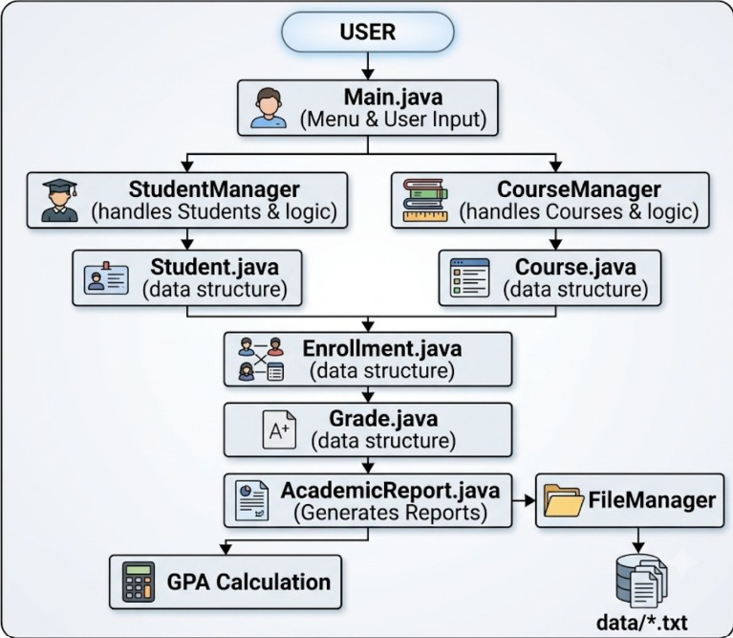

6. Application Workflow
Student Details
↓
Student Management
↓
Course Details
↓
Course Management
↓
Enrollment
↓
Grade Entry
↓
Academic Report
↓
GPA Calculation
↓
File Storage
Architecture Explanation
Main.java – controls the general execution and collects the inputs from the user.
Student.java – represents the data of student.
StudentManager.java – manages the student objects and provides search of students.
Course.java – represents the course data.
CourseManager.java – manages the courses and provides searching of courses.
Enrollment.java – relates the student and the course.
Grade.java – retains the grades and computes the grade points.
AcademicReport.java – prepares the academic report and calculates the GPA.
FileManager.java – stores the records in the text files.

- Use Case Diagram
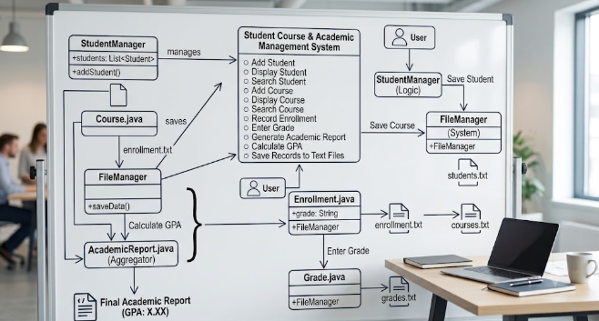

The Use Case Diagram represents the interaction between the user and the Student Course & Academic Management System. The user can manage student and course information, record enrollments and grades, generate academic reports, calculate GPA, and store records in text files.
- Class Diagram
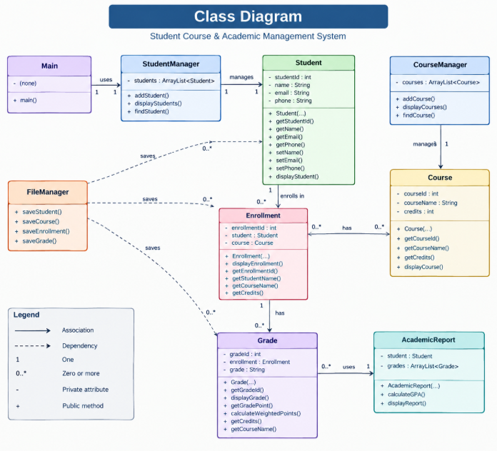

Sequence Diagram
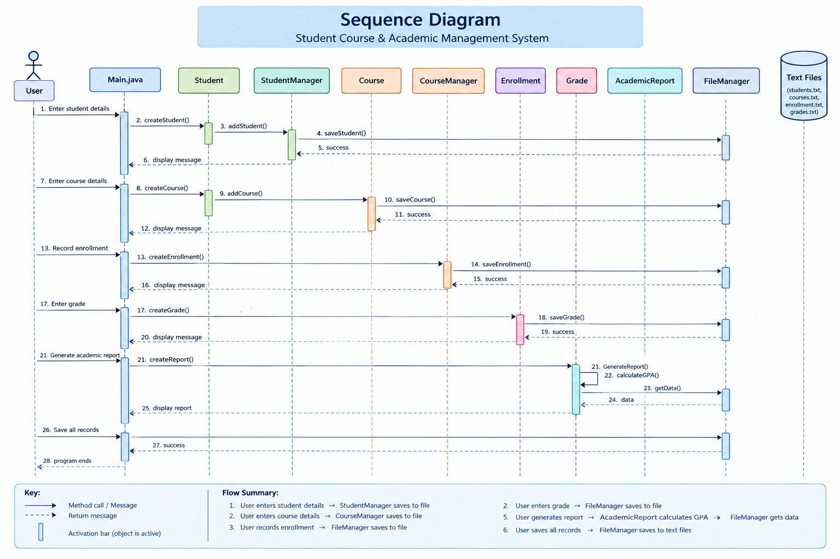

Project Structure
The project is structured into separate Java classes according to their responsibilities. The folder with the name execution accommodates the java files with sources of the code, and the data folder was used for the text files with the records. Screenshots of the working application were separated in a different folder.
student management system
execution
Main.java
Student.java
Course.java
Enrollment.java
Grade.java
AcademicReport.java
StudentManager.java
CourseManager.java
FileManager.java
data
students.txt
courses.txt
enrollment.txt
grades.txt
screenshots
Statement.md
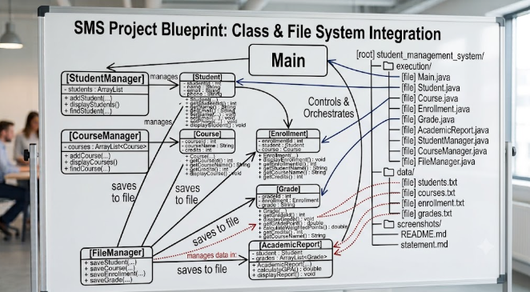

- Implementation
8.1 Student Management
The Student class holds the student's ID, name, email, and phone number while the StudentManager stores student objects and offers the capability to view and search for the student.
8.2 Course Management
We have the Course class that holds the course ID, course name, and credits. Similarly, the Course Manager is tasked with managing course objects, displaying, and searching for a course using the course ID.
8.3 Enrollment Management
The Enrollment class holds the student's data, the course they have enrolled, and the unique enrollment ID. The class offers a feature to display the enrollment's details.
8.4 Grade Management
The Grade class stores the grade of the student's enrollment. The grades are in letter form, for example., A, B, C, D, and E. Besides storing, the class converts the grades into grade points ranging from 4 to 0. We have calculated the weighted points using the formula below.
Weighted Points = Grade Point × Course Credits
8.5 Academic Report
The AcademicReport class takes a student's grade and credits to generate their grades report. In this class, we have implemented the GPA calculation formula as follows:
GPA = Total Weighted Points ÷ Total Credits
8.6 File Handling
The file handling module is managed by the File Manager. It uses the Java FileWriter to write information into files. The files are stored in text format.
The files include:
students.txt
courses.txt
enrollment.txt
grades.txt
8.7 Input Validation
Finally, the Main class offers the input validation feature for IDs, credits, and grades. When invalid input is detected, the application throws an error. For numeric values, the application only allows decimal numbers. On the other hand, grades are only allowed between A-E.

Screenshots & Results
Code-
Main.java
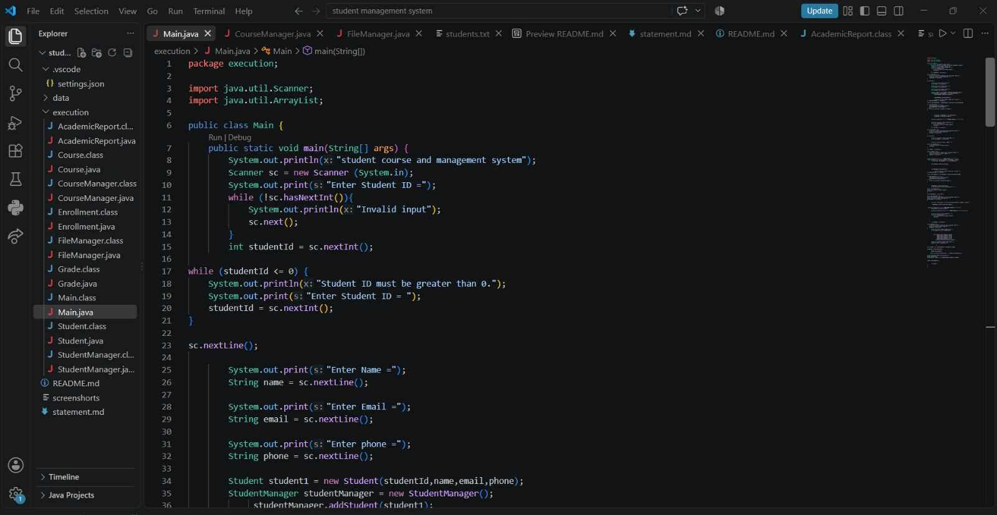
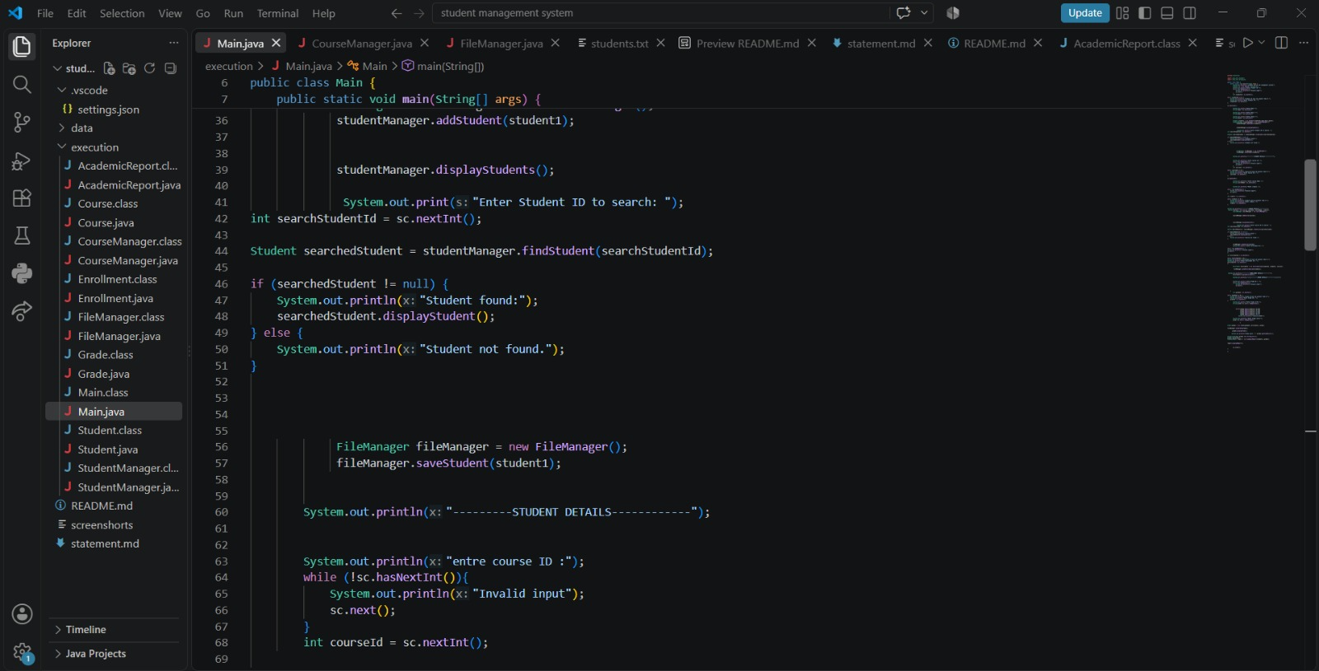
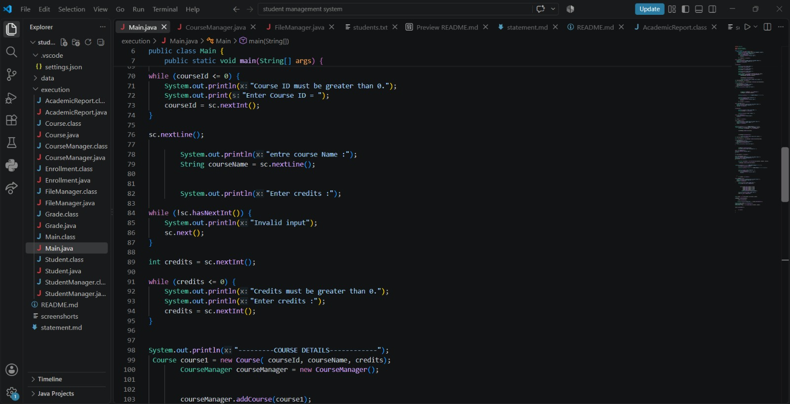
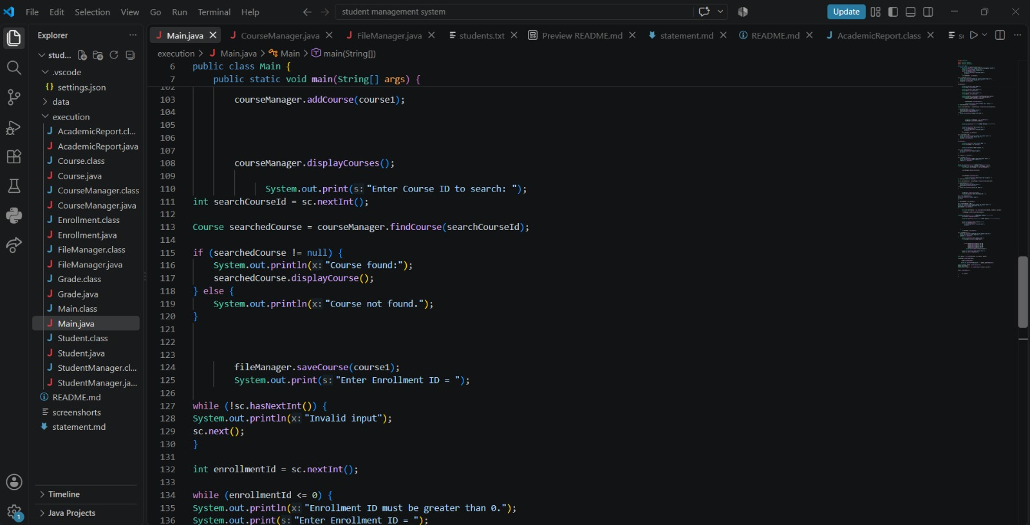
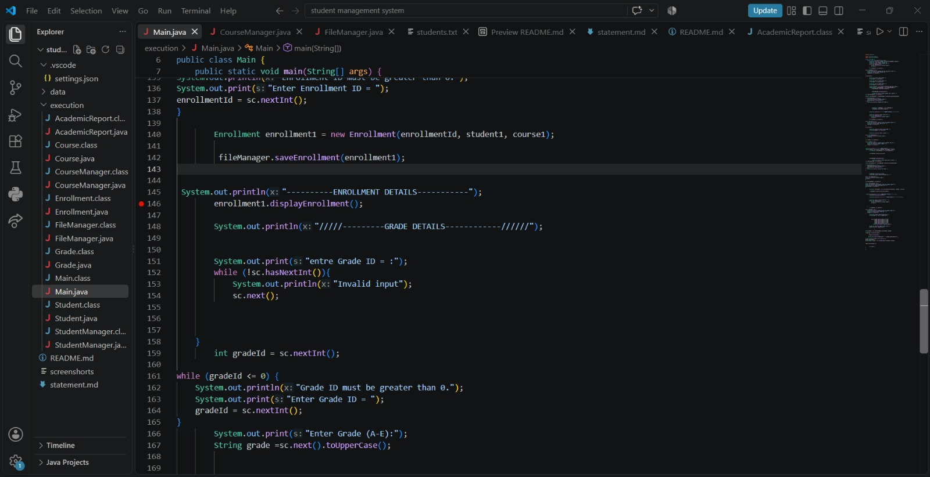
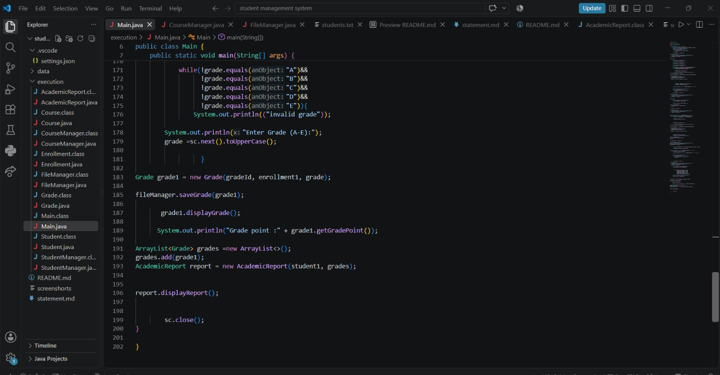

Output screenshort
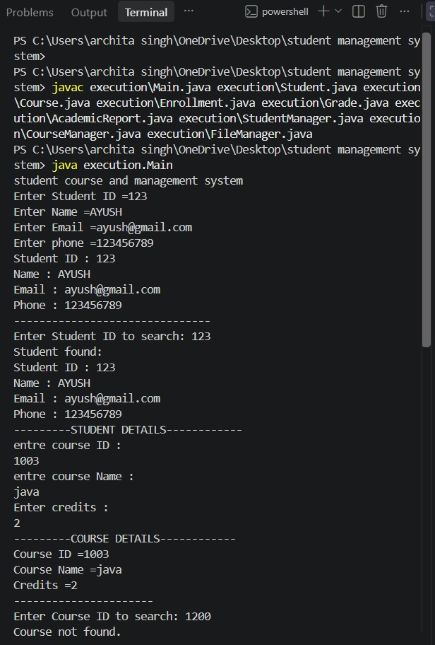

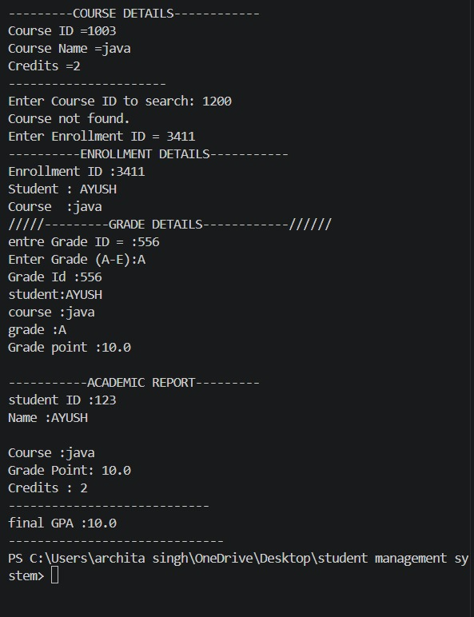

Data storage screenshort
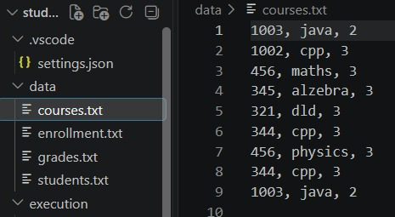
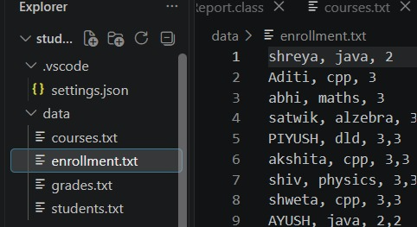
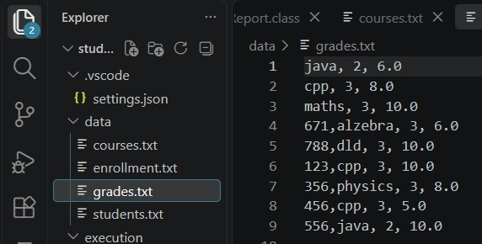
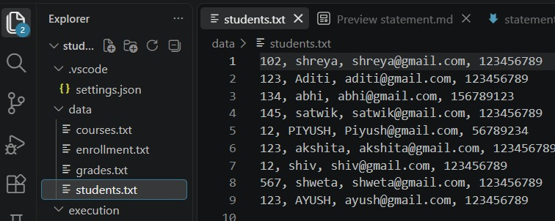

Problem Statement
Maintaining the student's data manually in an organized manner is a challenging task, including their courses, information about their registration, and grades. It becomes highly time-consuming to perform operations like searching for a particular record or calculating the average grade of a student.
The Student Course & Academic Management System is a java command line application that aims to offer an easy solution to manage students' basic academic information like grades and marks.
The application not only stores the grades of the student but also converts the grades into grade points and finally calculates the weighted average grade point as per the credit system of the respective course. It presents a complete academic report of the student with GPA.
All the records are stored in the text files using java file handling concepts.
The project demonstrates the implementation of Object-oriented programming, classes and objects, encapsulation, ArrayList, methods, input validation, exception handling, and file handling concepts in java.

- Objectives
The project has several objectives. They include:
Implementation of a student information system.
Course and credit management.
A record of student enrollments.
A record of student grades.
Converting grades into grade points.
Calculating weighted grade points using credit hours.
Generation of an academic report that contains the GPA.
Storage of records in text files.
Application of object-oriented programming concepts in a Java application.

- Functional Requirements
The system should provide the following set of functional requirements.
FR1 – Student Management
Add a student’s data: ID, name, email, and phone.
View student data.
Search for a student by Student ID.

FR2 – Course Management
Add a course: course ID, course name, and credits.
View course data.
Search for a course by Course ID.

FR3 – Enrollment Management
Enroll a student in a course.
View enrollment data.

FR4 – Grade Management
Add a grade for every course.
Convert a grade into grade points according to the grade point system.
Calculate weighted grade points for every course based on the credit hours.

FR5 – Academic Report
Generate a student’s academic report.
View the student’s course, grade, credit hours, and grade points.
Compute the student’s GPA.

FR6 – File Storage
Store student data in the students.txt file.
Store course data in the courses.txt file.
Store student enrollment data in the enrollment.txt file.
Store student’s grade data in the grades.txt file.

- Non-Functional Requirements
NFR1 – Usability
The application menues should use simple command prompt prompts and make it easy for a user to enter a command.
NFR2 – Reliability
The application should not crash when receiving incorrect input.
NFR3 – Maintainability
The application’s source code should be split into class definitions: Student, Course, Grade, and manager classes. This will make the code easy to read and maintain.
NFR4 – Error Handling
The application should be able to process numeric user input. It should also handle file reading/writing exceptions using C++ built-in exception handling mechanism.
NFR5 – Storage
Student records, course catalog, enrollment data, and student grades should be saved in separate text files upon exit or during application execution to persist data between application sessions.
NFR6 – Performance
The application should handle student and academic record management for a small scale efficiently.

5. System Architecture
The project follows a modular object-oriented architecture. The Main.java class controls the overall program flow and interacts with manager classes, entity classes, the academic report class, and the file storage component.

6. Application Workflow
Student Details
↓
Student Management
↓
Course Details
↓
Course Management
↓
Enrollment
↓
Grade Entry
↓
Academic Report
↓
GPA Calculation
↓
File Storage
Architecture Explanation
Main.java – controls the general execution and collects the inputs from the user.
Student.java – represents the data of student.
StudentManager.java – manages the student objects and provides search of students.
Course.java – represents the course data.
CourseManager.java – manages the courses and provides searching of courses.
Enrollment.java – relates the student and the course.
Grade.java – retains the grades and computes the grade points.
AcademicReport.java – prepares the academic report and calculates the GPA.
FileManager.java – stores the records in the text files.

- Use Case Diagram

The Use Case Diagram represents the interaction between the user and the Student Course & Academic Management System. The user can manage student and course information, record enrollments and grades, generate academic reports, calculate GPA, and store records in text files.
- Class Diagram

Sequence Diagram

7. Project Structure
The project is structured into separate Java classes according to their responsibilities. The folder with the name execution accommodates the java files with sources of the code, and the data folder was used for the text files with the records. Screenshots of the working application were separated in a different folder.
student management system
execution
Main.java
Student.java
Course.java
Enrollment.java
Grade.java
AcademicReport.java
StudentManager.java
CourseManager.java
FileManager.java
data
students.txt
courses.txt
enrollment.txt
grades.txt
screenshots
Statement.md

- Implementation
8.1 Student Management
The Student class holds the student's ID, name, email, and phone number while the StudentManager stores student objects and offers the capability to view and search for the student.
8.2 Course Management
We have the Course class that holds the course ID, course name, and credits. Similarly, the Course Manager is tasked with managing course objects, displaying, and searching for a course using the course ID.
8.3 Enrollment Management
The Enrollment class holds the student's data, the course they have enrolled, and the unique enrollment ID. The class offers a feature to display the enrollment's details.
8.4 Grade Management
The Grade class stores the grade of the student's enrollment. The grades are in letter form, for example., A, B, C, D, and E. Besides storing, the class converts the grades into grade points ranging from 4 to 0. We have calculated the weighted points using the formula below.
Weighted Points = Grade Point × Course Credits
8.5 Academic Report
The AcademicReport class takes a student's grade and credits to generate their grades report. In this class, we have implemented the GPA calculation formula as follows:
GPA = Total Weighted Points ÷ Total Credits
8.6 File Handling
The file handling module is managed by the File Manager. It uses the Java FileWriter to write information into files. The files are stored in text format.
The files include:
students.txt
courses.txt
enrollment.txt
grades.txt
8.7 Input Validation
Finally, the Main class offers the input validation feature for IDs, credits, and grades. When invalid input is detected, the application throws an error. For numeric values, the application only allows decimal numbers. On the other hand, grades are only allowed between A-E.

Screenshots & Results
Code-
Main.java

Output screenshort

Data storage screenshort
9. Testing
The application was tested by providing different types of valid and invalid inputs. The main functionalities, including student management, course management, enrollment, grade processing, GPA calculation, and file storage, were tested.
Testing Result
The testing confirmed that the major functionalities of the Student Course & Academic Management System work as expected. Input validation prevents invalid IDs, credits, and grades from being accepted. The system successfully generates the academic report, calculates GPA, and stores records in the required text files.

Challenges
Handling multiple Java classes
Breaking the project into several classes and establishing relationships between them required much attention.
Package and folder structure
Setting up the execution package and executing the java program with an appropriate package structure was initially difficult.
Input Validation
Dealing with invalid numerical inputs and only accepting grades from A to E required additional validation.
File Handling
Storing different record types in different text files requires using Java’s file classes and exception handling.
GPA Calculation
Calculating GPA using both grade points and course credits required a weighted-point calculation method.

Learnings & Key Takeaways

I was able to gain much experience through completing this project and applying my Java knowledge to create an application that addresses a real-world issue.

I had the chance to learn Object Oriented Programming with classes and objects.
Practice using ArrayList to store multiple objects.
Learn about encapsulation by applying private access modifiers and the getter and setter methods.
Apply loops, conditions, methods, and constructors.
Acquire new skills and knowledge about how to validate user input.
Learn how to use try-catch blocks to handle exceptions when working with files.
Gain experience by using FileWriter to write information into a file.
Applying my knowledge of creating multiple classes in one project and how they can interact with each other.
I also learned how to properly debug and test my programs. Additionally, I was able to improve my time management and documentation skills. Lastly, I learned how to work with Git and GitHub and push my code to the repository.

Future Enhancements

Add Update/Delete features for students and courses
Add multiple courses and grades for a student
Store data in a database (instead of a text file)
GUI interface for the application
User logins/authentication
Generate report cards for download

